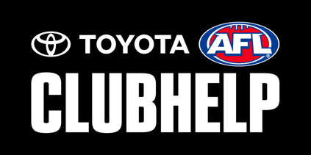

SOCIAL MEDIA COORDINATOR

Reports to: Committee

Purpose of the role

The Social Media Coordinator will communicate and interact with members, potential members and supporters. In this role you will build your club audience on social media and provide a sense of belonging between your club and its online supporters and followers.

Qualifications & Desirable Characteristics
- Strong computer/technology skills
- Understanding of how to create memes, photos and videos for social media
- Ability to plan what the club needs to communicate and when to communicate
- Effective and respectful communication
- Understanding or willing to learn existing policies (i.e. Codes of Conduct, Privacy Policy and Taking Images Policy

Duties and Responsibilities

Prior, during and post season the duties of the Social Media Coordinator may include but are not limited to:
- Create a communication strategy and break it down into pre, during and post season.
- Work out which social media platforms and strategies best suit the success of your communication strategy, club goals and objectives.
- Review and update the social media policy (code of conduct)
- Actively update the club’s social media channels throughout the week during the season (e.g. updating scores, results, achievements, injuries etc.)
- Promote club events and activities as well as special promotions or offers from sponsors.
- Team up with all divisions of the club to ensure their message and stories are being continually promoted and communicated.:
- End of season, review and remove access to the list of people who access to the club’s social media sites for those who no longer wish to have access.
- Review your communication strategy from the season and make recommendations or changes to the committee for next season.
- Review and update position description to ensure it continues to reflect the requirements of the role.

Time Commitment: 1 - 3 hours per week (during season) or as requested

